RailBuddy
AI-Powered Train ETA & Risk Prediction System
Team BotBrains
Smart India Hackathon 2026
Project Report

Abstract
Passenger rail information systems in India today mostly report binary or coarse status: on time, delayed, or cancelled. This leaves passengers unable to plan connecting journeys, and leaves station operators without early warning of developing congestion. RailBuddy addresses this by combining live operational data from official and community rail-data sources with four independently trained machine learning models — covering priority, traffic, weather, and speed — whose outputs are synthesised by the Gemini API into a single, confidence-scored estimated time of arrival and an associated risk assessment. The result is presented through a lightweight React dashboard designed to remain usable on lower-bandwidth Tier 2 and Tier 3 routes. This report documents the problem motivating RailBuddy, the system architecture, the technology stack, the machine learning methodology, the benefits delivered to different stakeholder groups, and the current state of the working prototype.

1. Introduction
Train delays across the Indian rail network are common, and the information passengers receive about them is often generic — a "delayed" notice with no indication of how long the delay will last or how confident that estimate is. This is especially disruptive on Tier 2 and Tier 3 routes, where connectivity is patchy and passengers have fewer alternative information sources. RailBuddy is a prediction system built to close that gap: it combines live train data with a set of trained machine learning models and a large language model to produce accurate, confidence-scored arrival time estimates and risk indicators, presented through a simple dashboard.
The motivation for the project came from observing how commuters currently manage uncertainty: repeatedly refreshing enquiry websites, calling station helplines, or relying on informal word-of-mouth about a train's status. None of these give a forward-looking, quantified sense of how a journey will unfold. RailBuddy's premise is that the raw data needed to make a much better prediction already exists across several public and semi-public sources — it simply is not being fused, modelled, and communicated well.

2. Problem Statement
Existing train tracking tools largely relay raw status updates (on time / delayed / cancelled) without predictive insight. Passengers cannot tell whether a "delayed" train will arrive in 10 minutes or 2 hours, cannot plan connecting travel with confidence, and receive no early warning of developing risk (e.g. congestion, weather, or scheduling conflicts) along a train's route.
This problem compounds for specific groups. Commuters connecting between trains have no way to judge whether they will make their connection. Senior citizens and non-technical users are often left to interpret cryptic status codes unaided. Passengers on Tier 2/3 routes, where connectivity can be intermittent, frequently cannot access even the limited information that does exist in a timely way.

3. Literature Review
The design of RailBuddy draws on two adjacent bodies of work: research on transportation delay prediction, and recent developments in large language models used as a reasoning and synthesis layer over structured outputs. Publicly available research repositories such as arXiv and ScienceDirect were used to review prior approaches to ETA prediction, including classical statistical delay-propagation models and more recent machine-learning approaches that treat delay prediction as a multivariate regression problem over operational features (train priority, section congestion, weather, and historical running-speed patterns).
A recurring theme in this literature is that single-model ETA predictors tend to be brittle when conditions deviate from their training distribution, and that ensembling multiple narrowly scoped models — each specialising in one class of signal — produces more robust and more explainable predictions. RailBuddy's architecture reflects this finding directly: rather than a single end-to-end model, it uses four narrowly scoped models whose outputs are reconciled by a separate synthesis layer.
On the generative AI side, Google's documentation for the Gemini API (ai.google.dev) informed the design of the synthesis layer, which uses Gemini not to predict numeric outputs directly, but to reason over the four models' structured outputs and produce a single coherent, natural-language-friendly prediction and risk summary.

4. Objectives
- Predict train arrival times with a quantified confidence score rather than a single point estimate.
- Identify and communicate risk factors that could affect a journey before they cause a missed connection.
- Translate complex ML outputs into plain-language, easy-to-understand status summaries.
- Build a system that remains useful on lower-connectivity Tier 2/3 routes.
- Keep the ML pipeline modular, so individual models can be retrained or replaced without affecting the rest of the system.

5. Proposed System Overview
RailBuddy is structured as a layered pipeline rather than a single monolithic predictor. A user-facing frontend collects a train number and forwards it to a backend service. The backend is responsible for retrieving both live and historical operational data, and for orchestrating calls to the machine learning layer. The ML layer itself is deliberately split into four narrow models, each responsible for one class of signal, so that the system's overall prediction quality degrades gracefully if any single upstream data source is temporarily unavailable. The outputs of these four models are then handed to the Gemini API, which acts as a synthesis and reasoning layer, producing the final ETA, a confidence score, and a risk summary. This result is cached in a dynamic prediction engine and rendered to the user through a dashboard.

6. System Architecture
The diagram below shows the full request lifecycle, from the moment a user submits a train number through to the dashboard rendering a prediction.
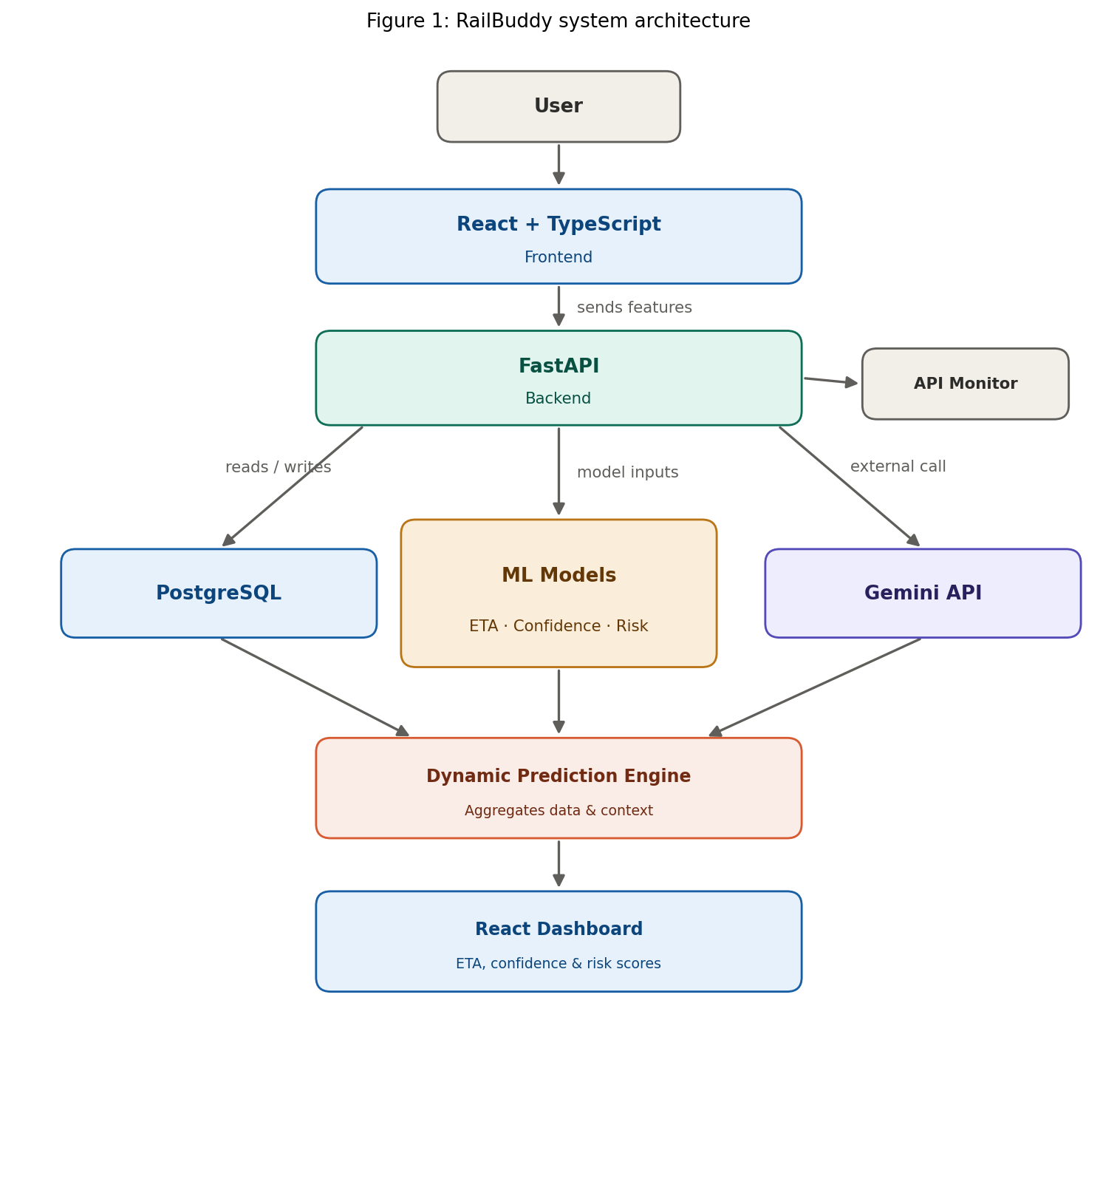
Figure 1: RailBuddy system architecture

6.1 Data and prediction flow
- User submits a train number through the frontend.
- Frontend sends the request to the FastAPI backend.
- Backend reads live and historical data from PostgreSQL, Train Data API, and RailRadar API.
- Feature data is passed to four ML models — priority, traffic, weather, and speed.
- Model outputs are sent to the Gemini API, which analyses them together and predicts train timing.
- The dynamic prediction engine aggregates the result with context and confidence scoring.
- The React dashboard renders the final ETA, confidence score, and risk indicators.

6.2 Component responsibilities
- Frontend (React + TypeScript): Handles user input, displays predictions, and stays responsive on low-bandwidth connections.
- Backend (FastAPI): Exposes the prediction API, authenticates and validates requests, and orchestrates calls to the data and ML layers.
- PostgreSQL: Stores historical train running data and cached predictions for fast repeat lookups.
- Train Data API / RailRadar API: Supply live and historical train position, schedule, and running-status data.
- API Monitor: Continuously watches upstream API health so degraded data sources are flagged rather than silently trusted.

7. Technology Stack
The table below summarises the technologies used at each layer of the system.
Layer | Technologies
Frontend | React, TypeScript, Tailwind CSS
Backend | FastAPI, Python, PostgreSQL
Data sources | Train Data API, RailRadar API
ML models | Four models trained on train data: priority, traffic, weather, speed
AI layer | Google Gemini API — analyses the outputs of the four ML models and predicts train timing
Deployment | GitHub-based deployment; live prototype hosted on Vercel

8. Machine Learning Methodology
Rather than a single model predicting ETA directly from raw features, RailBuddy uses four independently trained models, each scoring one class of signal known to influence train punctuality. Their outputs are not simply averaged — they are passed to the Gemini API, which reasons over all four scores together with contextual information to produce the final prediction and an associated risk narrative.
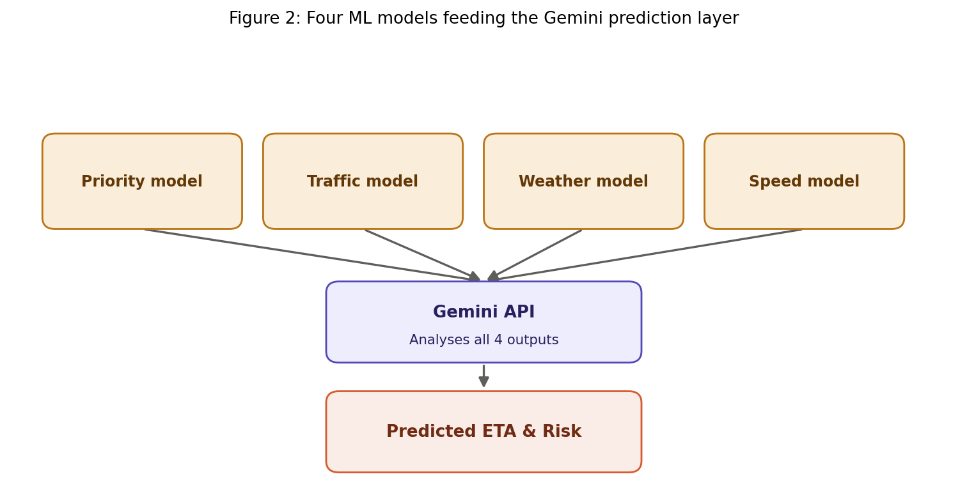
Figure 2: Four ML models feeding the Gemini synthesis layer
Model | What it scores
Priority | The scheduling priority of a train relative to others sharing the same section of track.
Traffic | Current congestion along the train's route, based on live and historical section occupancy.
Weather | Weather conditions along the route that are known to correlate with delays (fog, heavy rain, etc.).
Speed | The train's recent and historical speed profile against the scheduled run.

8.1 Why four separate models
Splitting the problem into four narrowly scoped models keeps each one simpler to train, validate, and retrain independently. If, for example, a new weather data source becomes available, only the weather model needs to be retrained — the priority, traffic, and speed models, and the synthesis layer, are unaffected. This also makes the system's behaviour easier to audit: if a prediction looks wrong, the four intermediate scores can be inspected individually to see which signal drove the result.

8.2 Role of the Gemini API
The Gemini API is used as a reasoning layer on top of the four models rather than as a replacement for them. Its inputs are the four structured model outputs plus lightweight contextual information (route, time of day, station). Its output is a single predicted arrival time, a confidence score, and a short natural-language risk summary that the frontend can render directly or convert into a spoken alert for accessibility.

9. Key Features
- Confidence-scored ETA predictions instead of a single fixed time.
- Risk indicators derived from priority, traffic, weather, and speed signals.
- Plain-language status summaries generated by the Gemini API.
- A lightweight dashboard designed to remain usable on lower-bandwidth connections.
- A modular backend that can incorporate new data sources without retraining the entire pipeline.

10. Key Benefits
The benefits of the solution fall into three broad categories — accuracy, technological innovation, and reduction of time consumption — which in turn produce social and economic value, as shown below.
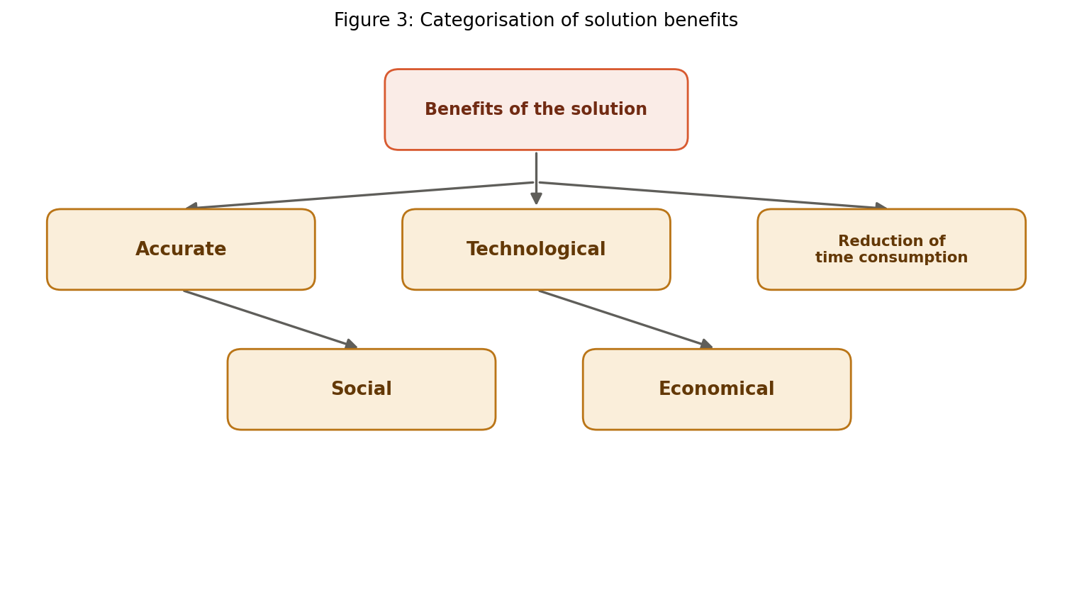
Figure 3: Categorisation of solution benefits

10.1 Accuracy & predictive precision
- Dynamic feature cross-verification across multiple live data sources.
- Uncertainty quantification instead of a single fixed ETA.
- Cross-source validation between train data and RailRadar feeds.

10.2 Technological innovation
- A modular ML pipeline — each of the four models can be retrained independently.
- Context-aware generative AI (Gemini) synthesising model outputs into a final prediction.
- A modern, responsive React-based user interface.

10.3 Time savings
- Elimination of idle platform waiting through accurate ETAs.
- Proactive rerouting suggestions when a delay is detected.
- Near real-time information processing.

10.4 Economic value
- Prevents missed connections and the financial losses that follow.
- Reduces station infrastructure strain from platform overcrowding.
- Supports data-driven maintenance and fleet planning from risk-model outputs.

10.5 Social & accessibility impact
- Extends reliable predictions to Tier 2 and Tier 3 routes, which are typically underserved.
- Reduces commuter stress and anxiety around uncertain delays.
- Plain-language, voice-friendly summaries make technical predictions accessible to non-technical and senior users.

11. Implementation Details

11.1 Frontend
The frontend is built with React and TypeScript, styled with Tailwind CSS. It is intentionally kept lightweight: a single search entry point for a train number, a results view showing the predicted ETA, confidence score, and risk summary, and minimal client-side state so that the page remains fast to load on constrained connections.

11.2 Backend
The backend is built with FastAPI on Python, chosen for its asynchronous request handling and its natural fit with the Python-based ML tooling used to train and serve the four models. PostgreSQL stores historical running data and cached predictions, reducing repeated calls to external data providers for frequently queried trains.

11.3 Deployment
The codebase is deployed through GitHub-based deployment workflows, and a live prototype is currently hosted on Vercel for demonstration and testing purposes.

12. Testing & Validation
The prototype has been exercised manually against a range of train numbers to confirm that the end-to-end flow — from a submitted train number through to a rendered prediction — completes correctly, including the fallback behaviour of the API Monitor when an upstream data source is slow or unavailable. Formal accuracy benchmarking against historical running data is part of ongoing work; current validation has focused on functional correctness of the pipeline rather than statistical accuracy claims, and this report does not state specific accuracy figures until that benchmarking is complete.

13. Results and Observations
In its current state, RailBuddy successfully demonstrates the full pipeline described in Section 6: a train number entered on the frontend results in a rendered prediction that combines all four model outputs through the Gemini synthesis layer. The modular design has, in practice, made it straightforward to swap data sources during development without needing to touch the frontend or the other three models — validating the architectural decision described in Section 8.1.

14. Prototype
A working prototype of RailBuddy is deployed and publicly accessible:
- Live prototype (RailBuddy) — https://railbuddy.vercel.app/

15. Feasibility and Viability

15.1 Technical feasibility
All components of RailBuddy rely on established, widely supported technologies — React and TypeScript on the frontend, FastAPI and PostgreSQL on the backend, and the publicly documented Gemini API for the synthesis layer. None of the four ML models require exotic infrastructure; each is a narrowly scoped model that can be trained and served on standard compute. The modular split between the four models and the synthesis layer (Section 8.1) also means the system can be built and tested incrementally, reducing technical risk during development.

15.2 Operational feasibility
The system depends on two categories of external data: official sources (the Train Data API) and community-maintained sources (RailRadar API), both of which are already in active use elsewhere. The API Monitor component (Section 6.2) is specifically included to make the system operationally resilient — if one upstream source degrades or goes offline, the system can flag reduced confidence rather than fail outright. The dashboard's lightweight design keeps operational requirements modest, which matters for the lower-connectivity Tier 2/3 routes the project targets.

15.3 Economic feasibility
The technology stack is built entirely on open-source frameworks (React, FastAPI, PostgreSQL) and pay-as-you-go APIs (Gemini), which keeps upfront infrastructure cost low and lets cost scale with actual usage rather than requiring large fixed investment. Section 10.4 outlines the downstream economic value this can unlock for both passengers and station operators — preventing missed connections, reducing platform overcrowding, and supporting data-driven maintenance planning — which offsets the relatively modest cost of running the system.

15.4 Potential challenges and risks
- Upstream data sources (Train Data API, RailRadar API) may have rate limits, downtime, or coverage gaps on less-monitored routes.
- Model accuracy depends on the quality and volume of historical training data, which may be sparser for some Tier 2/3 routes.
- Connectivity constraints on the routes the project specifically targets could limit real-time usage in the field.
- Reliance on a third-party LLM (Gemini) introduces a dependency on external API availability and pricing changes.

15.5 Strategies to overcome challenges
- The API Monitor and modular model design let the system degrade gracefully — flagging lower confidence — instead of failing when one data source is unavailable.
- Caching predictions and historical data in PostgreSQL reduces repeated dependence on live upstream calls for frequently queried trains.
- The lightweight dashboard and planned offline caching (Section 16) directly address low-connectivity usage.
- Because the synthesis layer is decoupled from the four scoring models, the LLM provider could be swapped if needed without retraining the underlying models.

16. Future Scope
- Formal accuracy benchmarking of each of the four models against historical running data.
- Expanding data coverage to additional Tier 2/3 routes.
- A native mobile app to complement the web dashboard, with offline caching for low-connectivity zones.
- Push notifications for developing risk on a passenger's saved journeys.
- Multilingual voice alerts built on the existing Gemini-generated summaries.

17. Conclusion
RailBuddy demonstrates that combining conventional ML models with a large language model layer can turn raw, fragmented train data into predictions that are both more accurate and more understandable than existing tools. By focusing on confidence-scored ETAs, early risk detection, and accessibility for non-technical users, the system directly targets the gap between what passengers are currently told and what they actually need to plan their journeys — particularly on the Tier 2 and Tier 3 routes most underserved by existing infrastructure.

18. References

18.1 Official source
- Indian Railways National Train Enquiry System (NTES) — https://enquiry.indianrail.gov.in

18.2 Research papers used
- ScienceDirect — https://www.sciencedirect.com
- arXiv — https://arxiv.org

18.3 AI & LLM references
- Google AI for Developers (Gemini API) — https://ai.google.dev

18.4 Other references
- Where is my Train — https://www.whereismytrain.in
- IRCTC — Indian Railway Catering and Tourism Corporation — https://www.irctc.co.in

